**HANDS ON - SQL (Day2)**

**Name : Podutur Lahari - DE126**

**Date : 05-11-2024**

Create a Sample Database and run the queries

**Code :**

-- Create database

CREATE DATABASE day2db;

-- Create Employees table

CREATE TABLE Employees (

EmployeeID INT PRIMARY KEY,

FirstName NVARCHAR(50),

LastName NVARCHAR(50),

Age INT,

Department NVARCHAR(50),

Salary DECIMAL(10, 2)

);

-- Insert sample data

INSERT INTO Employees (EmployeeID, FirstName, LastName, Age, Department, Salary) VALUES

(1, 'Arjun', 'Reddy', 30, 'HR', 55000),

(2, 'Manoj', 'Nair', 25, 'IT', 60000),

(3, 'Lakshmi', 'Iyer', 40, 'Finance', 70000),

(4, 'Venkatesh', 'Raj', 35, 'IT', 65000),

(5, 'Sneha', 'Menon', 28, 'HR', 58000);

--1. Storing Data in a Table (Inserting Data)

-- Insert another row into Employees table

INSERT INTO Employees (EmployeeID, FirstName, LastName, Age, Department, Salary)

VALUES (6, 'Karthik', 'Mohan', 50, 'Finance', 80000);

-- Check the updated table

SELECT * FROM Employees;

--2. Updating Data in a Table

-- Update Manoj's salary to 62000

UPDATE Employees

SET Salary = 62000

WHERE FirstName = 'Manoj';

-- Check the updated table

SELECT * FROM Employees;

--3. Deleting Data from a Table

-- Delete Lakshmi's record

DELETE FROM Employees

WHERE FirstName = 'Lakshmi';

-- Check the updated table

SELECT * FROM Employees;

--4. Retrieving Specific Attributes

-- Retrieve only FirstName and Department

SELECT FirstName, Department FROM Employees;

--5. Retrieving Selected Rows

-- Retrieve employees older than 30

SELECT * FROM Employees

WHERE Age > 30;

--6. Filtering Data: WHERE Clauses

-- Retrieve employees from the IT department

SELECT * FROM Employees

WHERE Department = 'IT';

--7. Filtering Data: IN, DISTINCT, AND, OR, BETWEEN, LIKE

-- Retrieve employees from IT or HR departments

SELECT * FROM Employees

WHERE Department IN ('IT', 'HR');

-- BETWEEN

-- Retrieve employees with salary between 55000 and 70000

SELECT * FROM Employees

WHERE Salary BETWEEN 55000 AND 70000;

-- LIKE

-- Retrieve employees whose FirstName starts with 'A'

SELECT * FROM Employees

WHERE FirstName LIKE 'A%';

-- Column & Table Aliases

-- Use aliases for columns and table

SELECT E.FirstName AS Name, E.Department AS Dept

FROM Employees AS E;

**Create Database :** 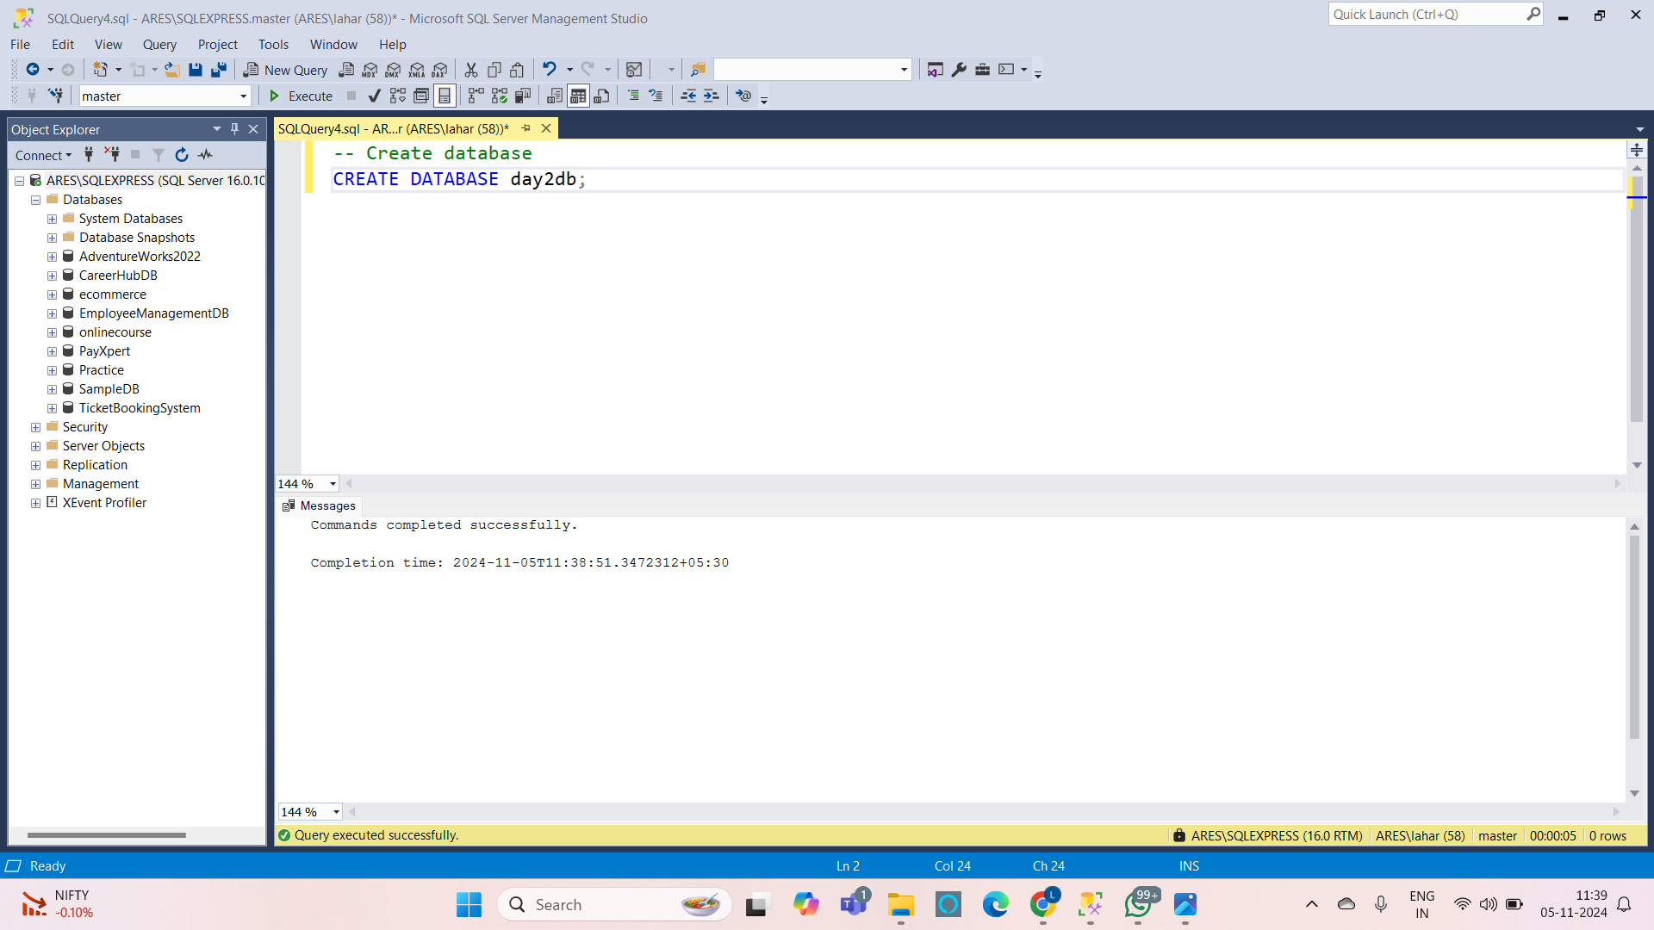

**Create table :**

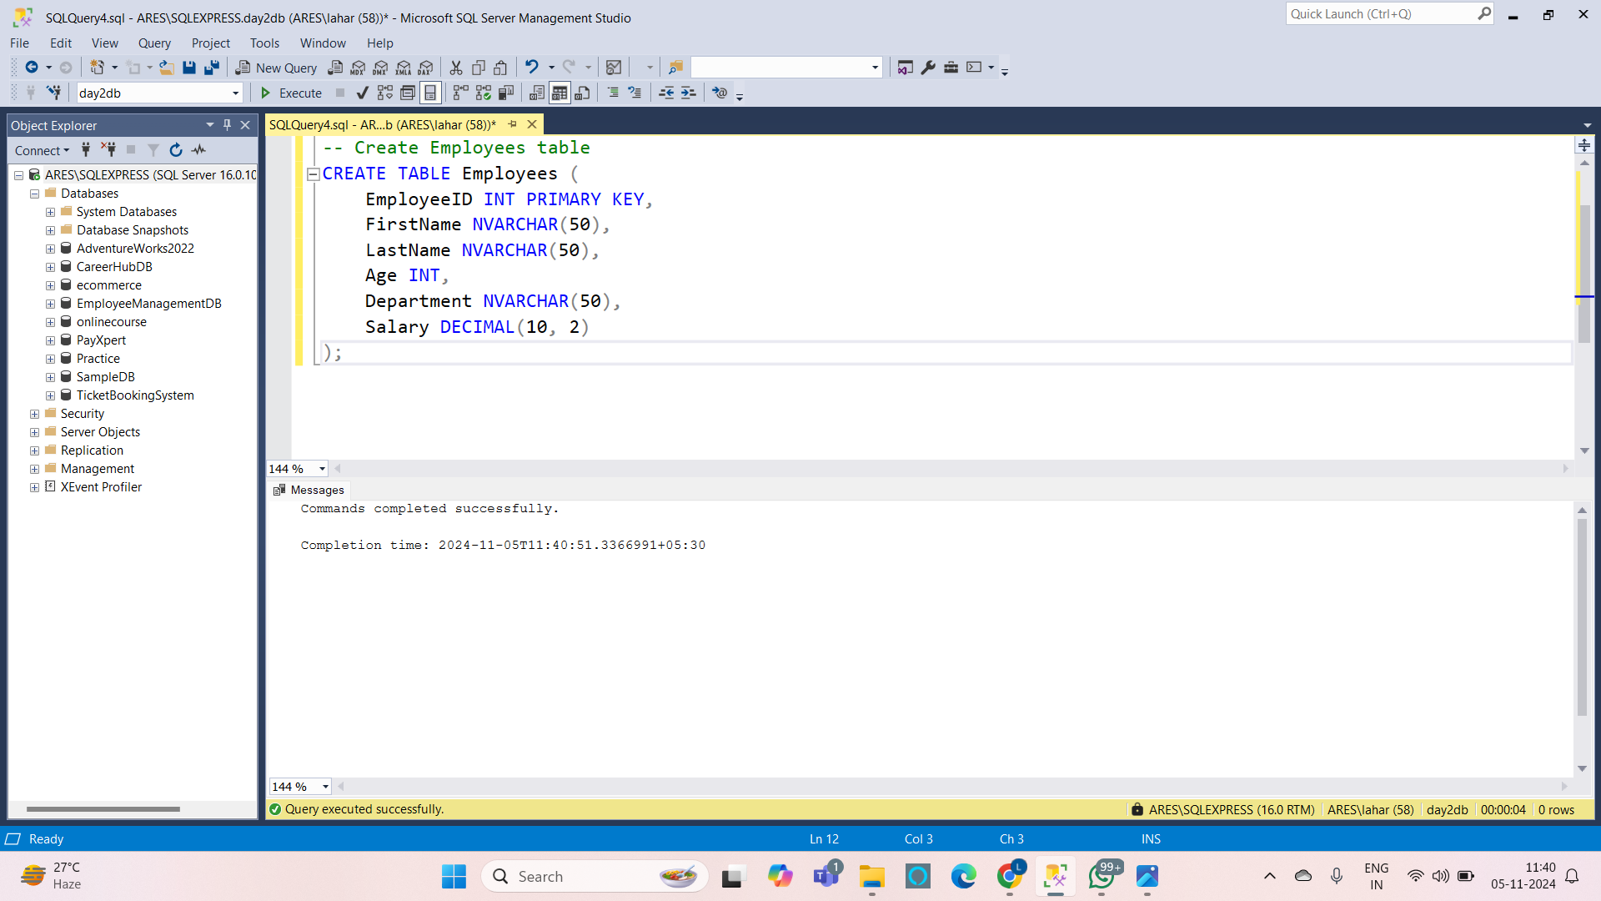

**Insert values into tables :** 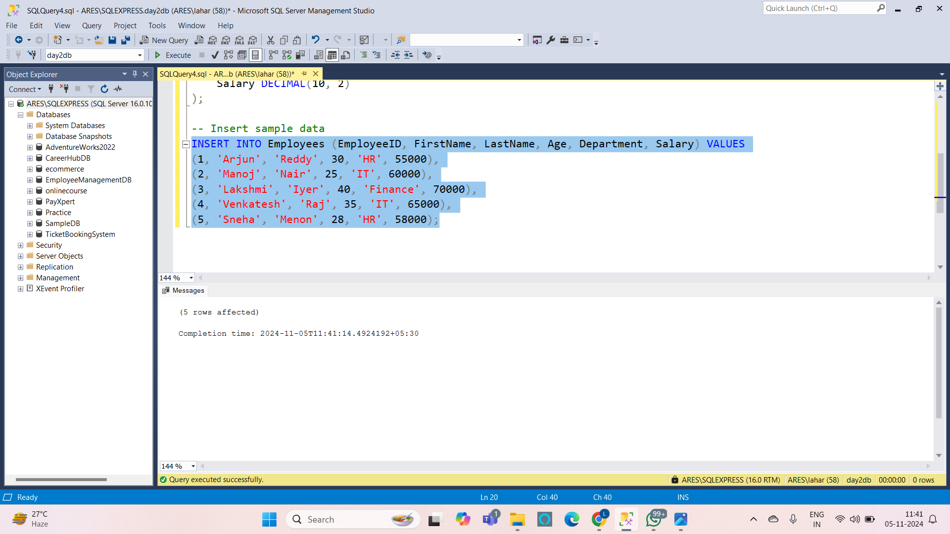

**1. Storing Data in a Table :**

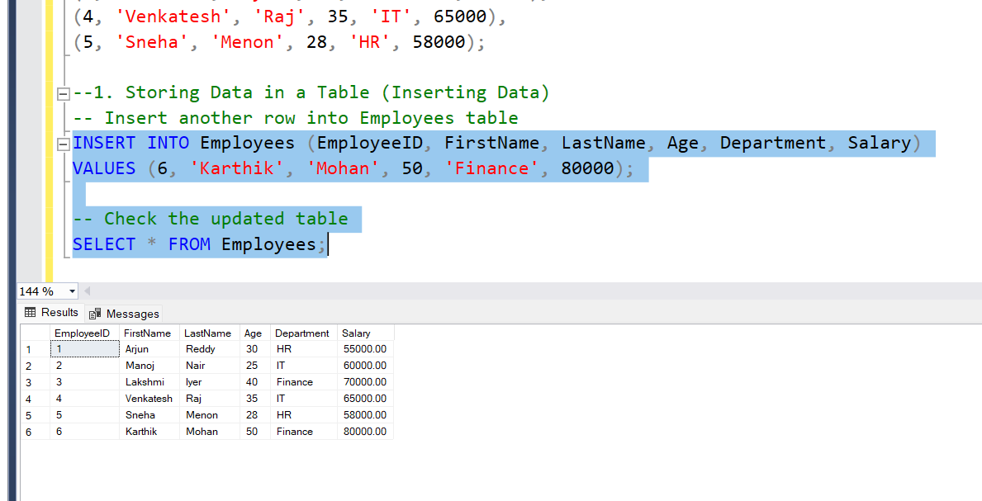

**2. Updating Data in a Table :** 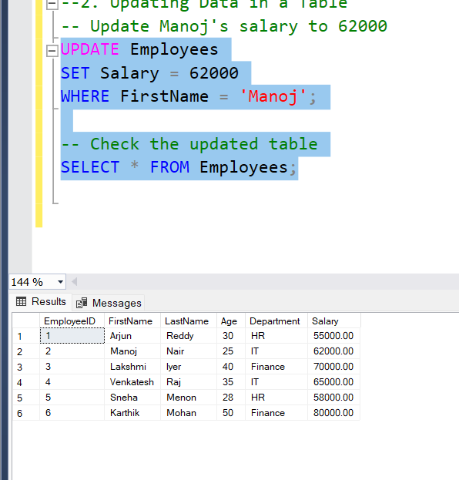

**3. Deleting Data from a Table :** 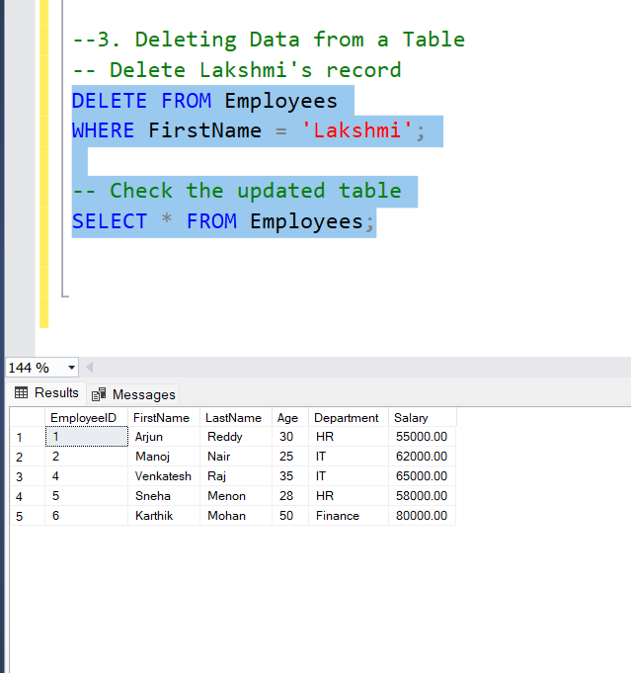

**4. Retrieving Specific Attributes :** 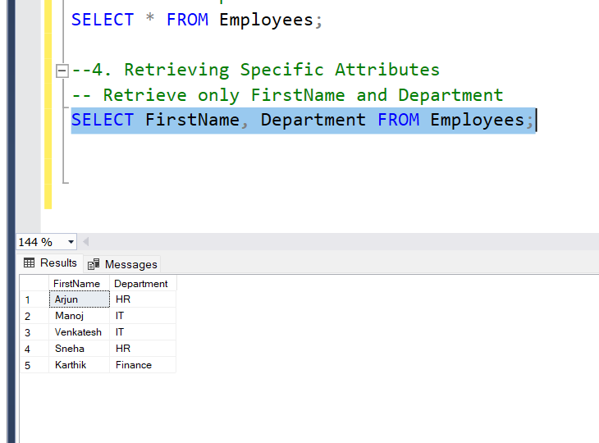

**5. Retrieving Selected Rows :**

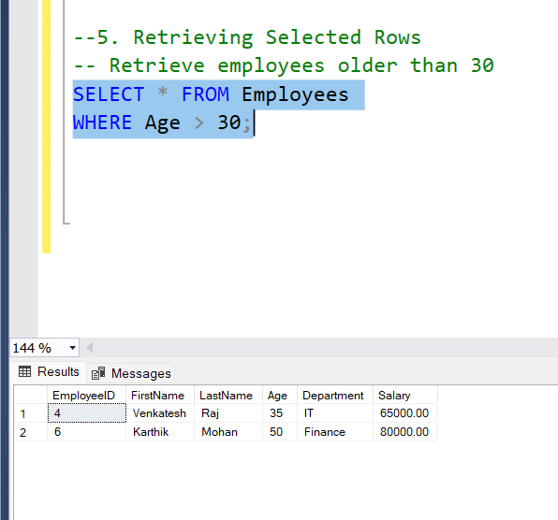

**6. Filtering Data:WHERE Clauses :**

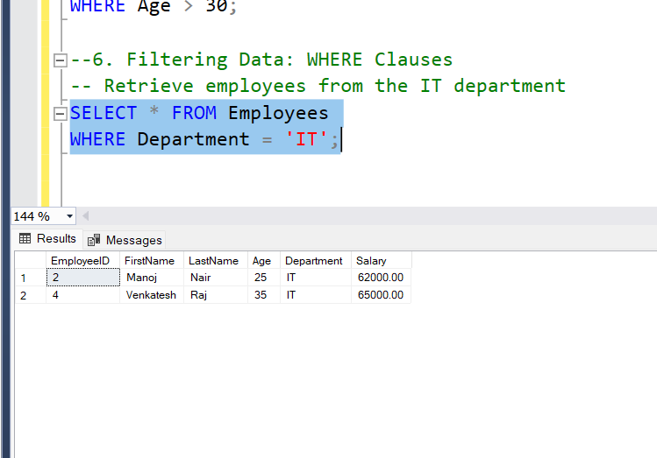

**7. Filtering Data:IN,DISTINCT,AND,OR,IN,BETWEEN,LIKE,Column & table aliases :**

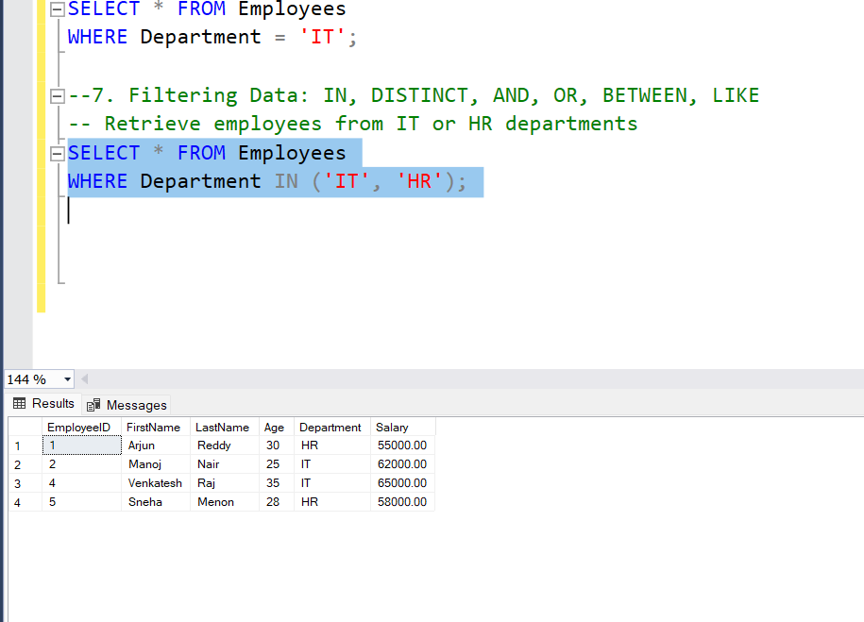

**BETWEEN :**

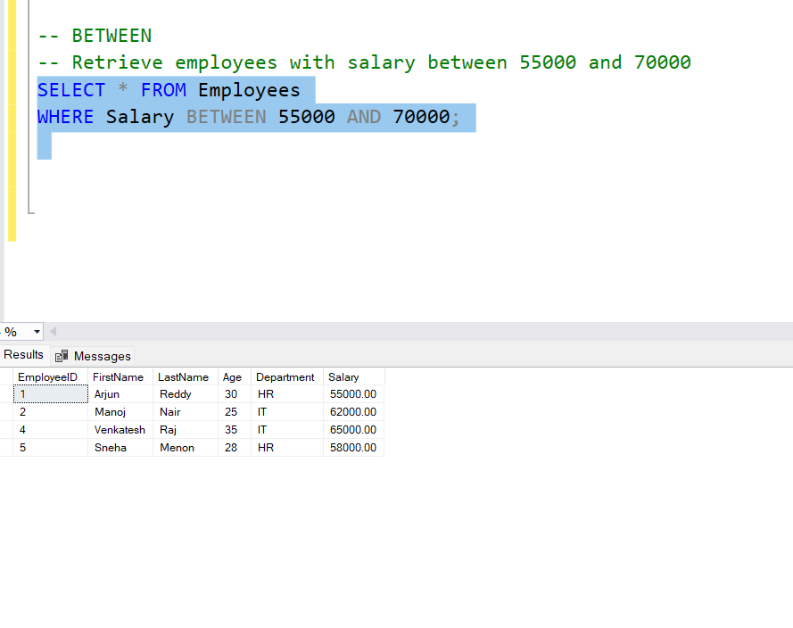

**LIKE :**

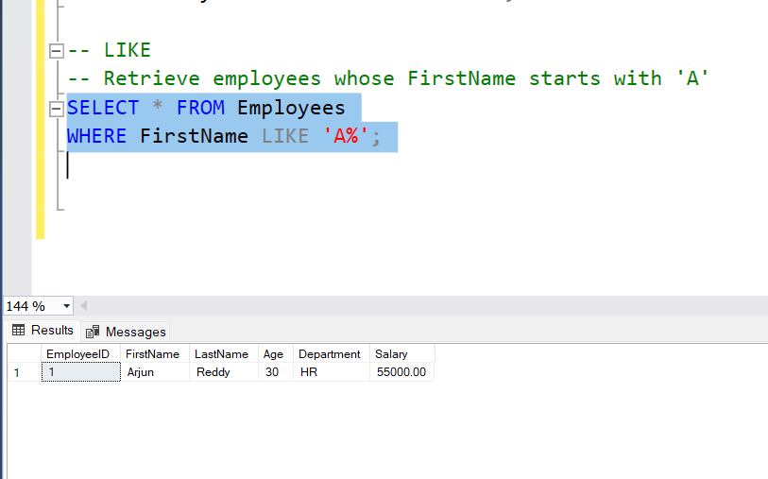

**Column and Table Aliases :**